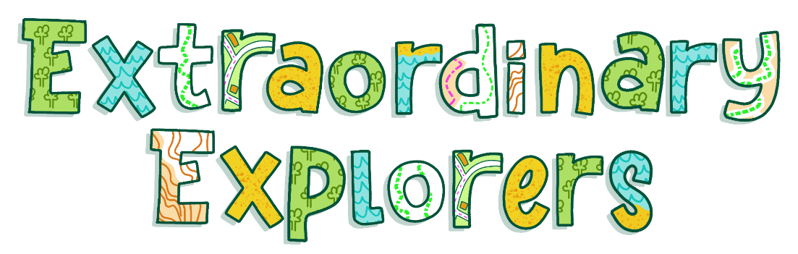

FREE summer fun for your child, plus a swim voucher & rewards!
Dear Parent/Carer,
Looking for something fun, free and rewarding to keep your child engaged this summer?
‘Yes’ we hear you cry!
Join the Cornwall Reading Challenge 2026!
WAIT! Don’t stop reading because we said Reading Challenge, we promise it’s worth reading on…
From Saturday 11 July, children of all ages can sign up at their local library and start an exciting summer adventure with books.

Why sign up? Because it’s packed with rewards…
- FREE to join
- FREE swim voucher just for signing up
- Collect stickers and rewards along the way
- Children can read about the things they love in a way that works for them.
- Earn a certificate and medal for completing the challenge
- Finishers receive a Treasure Trail worth £9.99!
Choose your challenge
- Reading Quest – read 6 books and unlock rewards
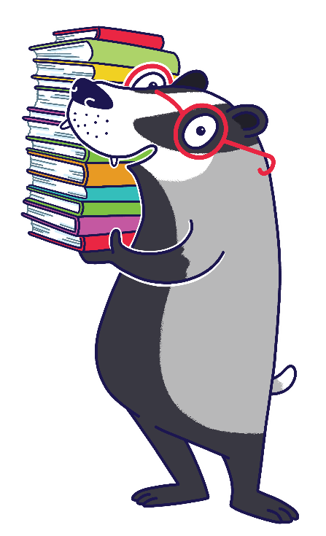
- One and All Challenge – an accessible challenge. It’s our flexible option so every child can take part and succeed.
And more than just reading…
- Build confidence and keep reading skills strong over summer
- Discover new books, authors and ideas
- Take part in FREE library activities all summer long
To get started simply visit your local library from 11 July to sign up.
Don’t miss out – thousands of Cornwall children took part last year.
Let’s make this summer even bigger!
It’s fun. It’s free. And there’s a reward waiting from day one.

See you there. The Cornwall Libraries Team.

